|  |  |  |  |  |  |
| --- | --- | --- | --- | --- | --- |
| Date | 7-Dec-22 | | | Tester Name | Mohammad Yusuf |
| Environment | Penfax - Test | | | Login used |  |
| Operating System | Windows | Version: | Update: | | |
| Software Used | Select Software | Version: | Update: | | |
| Select Software | Version: | Update: | | |
| Release version |  | | | | |
| Title |  | | | | |
| Test Type | Regression | | | | |
| Test Scenario |  | | | | |
|  |  | | | | |
| Expected Results |  | | | | |
| Pass/Fail | Select | | | JIRA# | N/A |

Describe your steps with screenshots:   
Retired and Married PSSP member

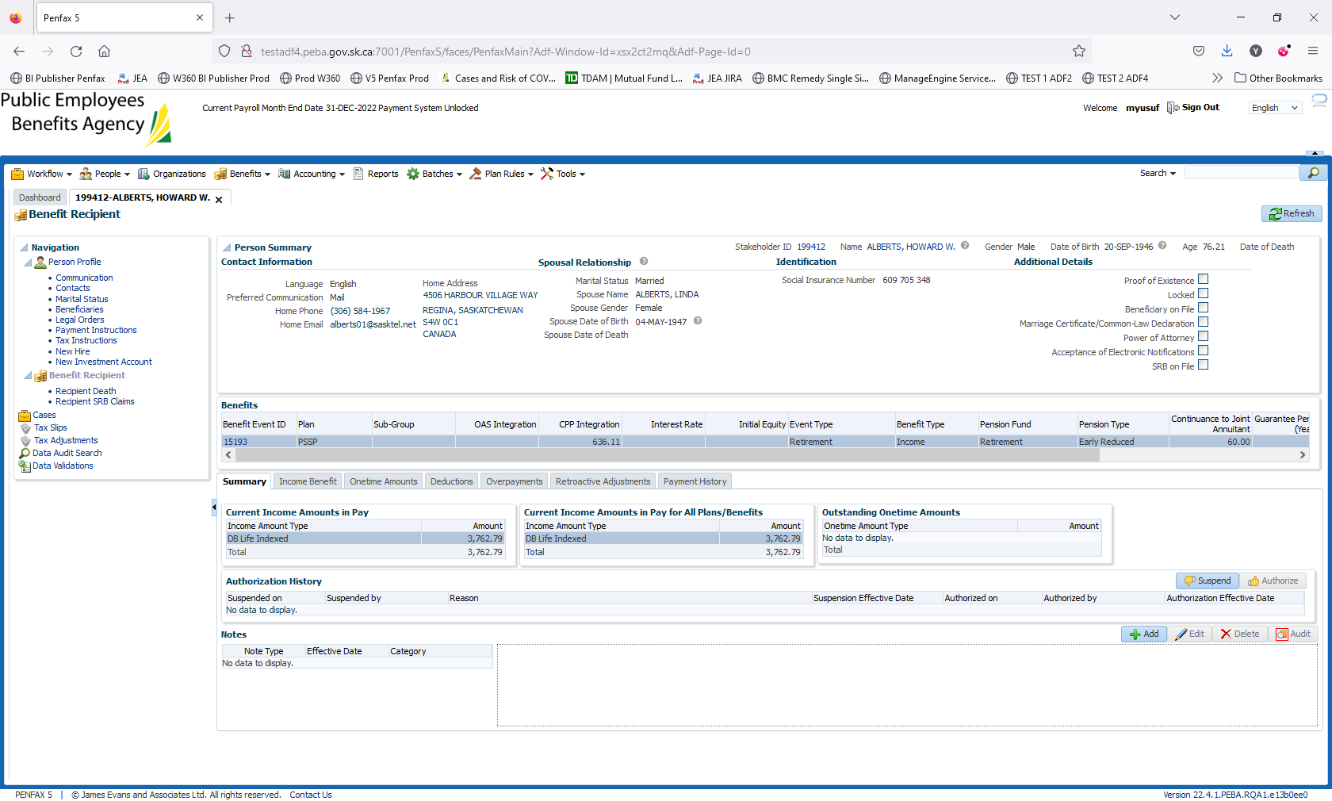

Add the Beneficiary

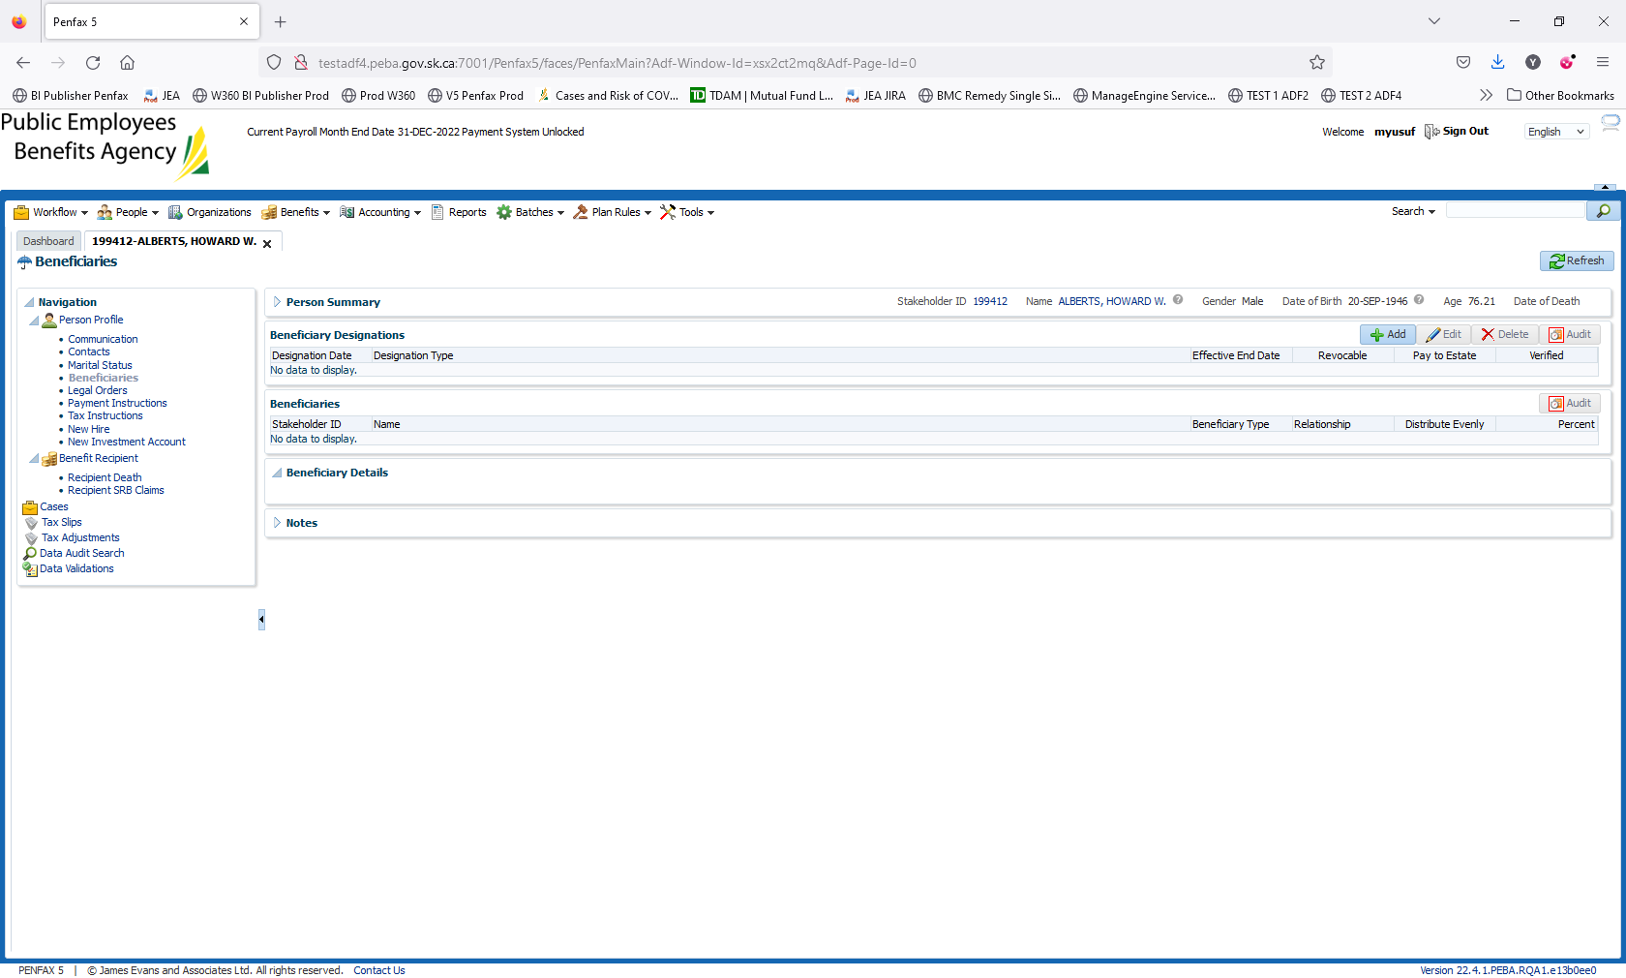

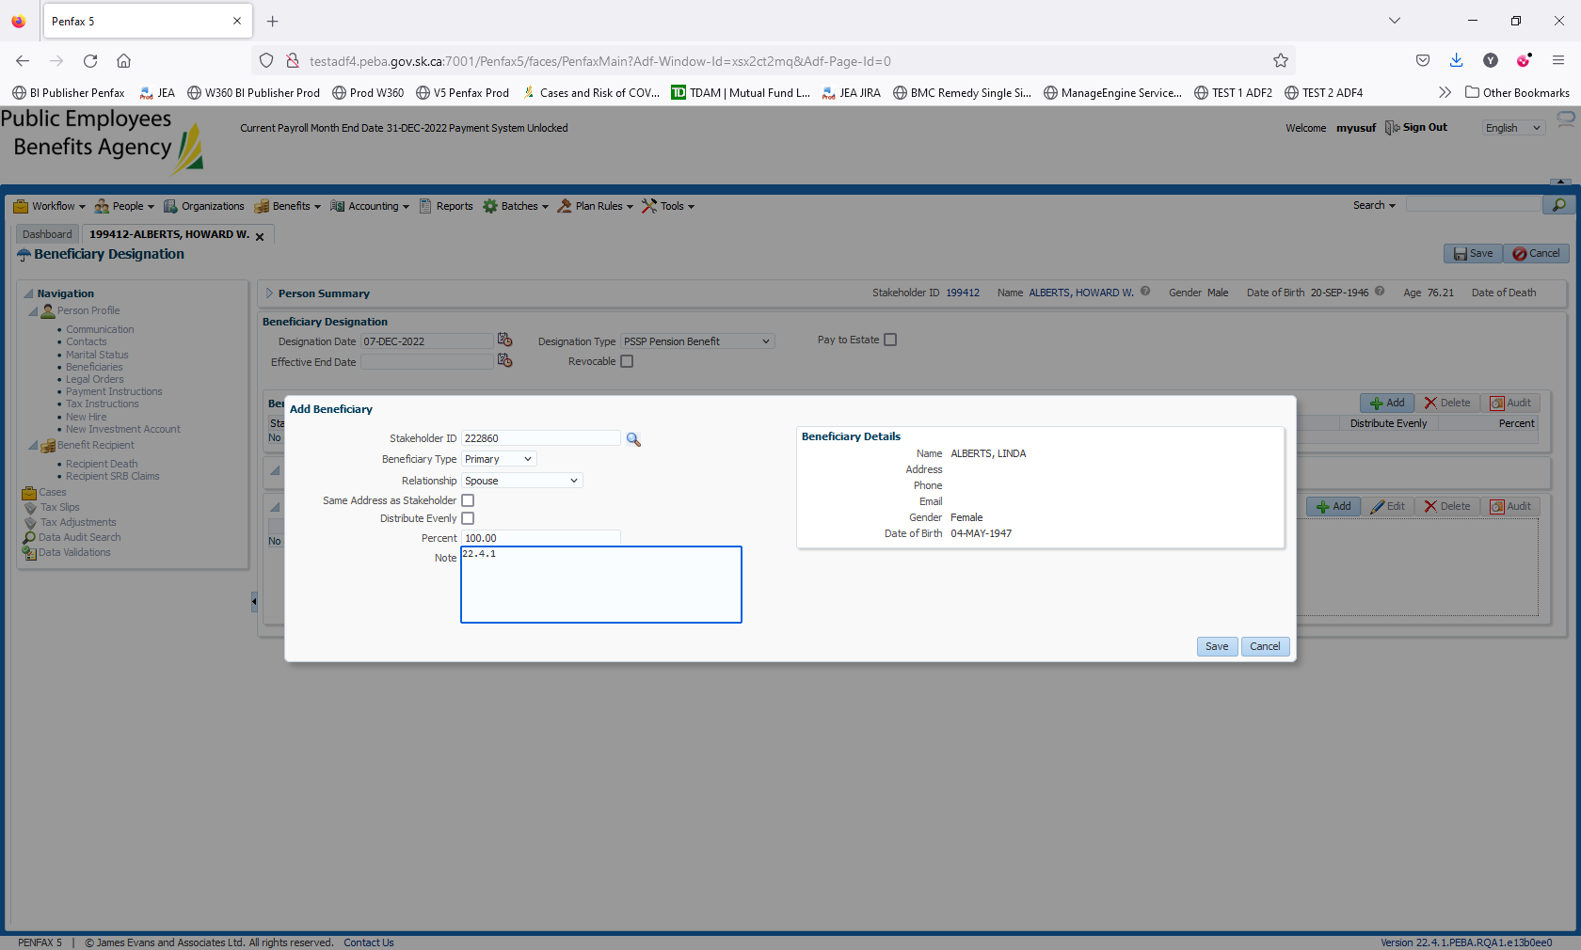

Save it

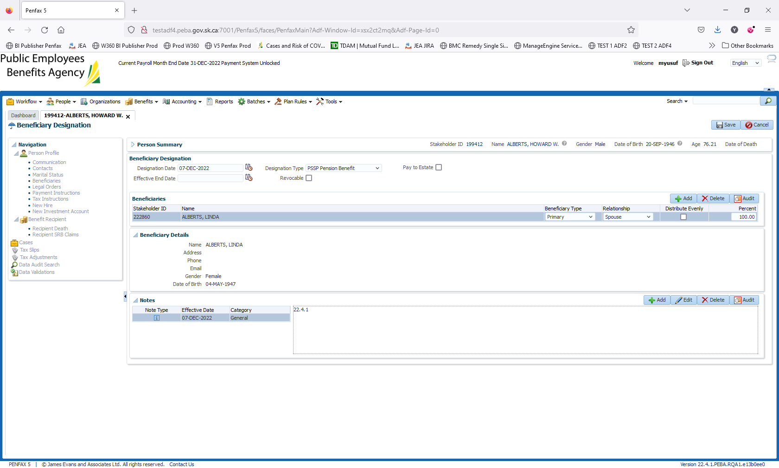

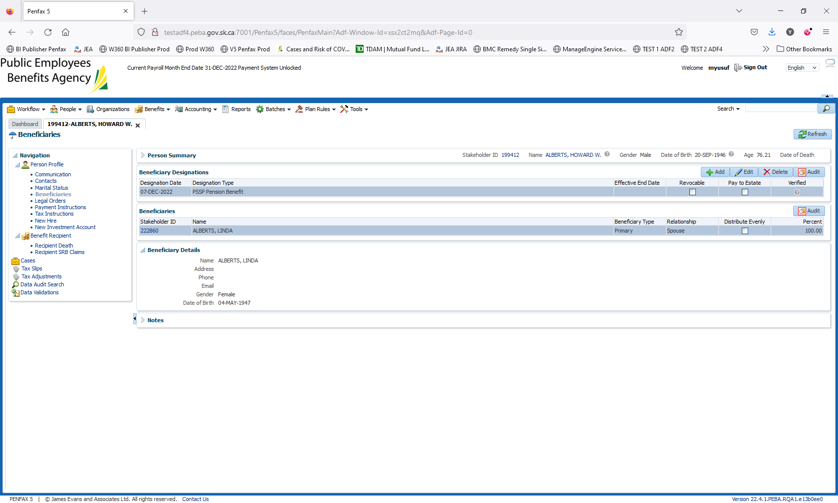

Enter the date of Death and run the calculation.

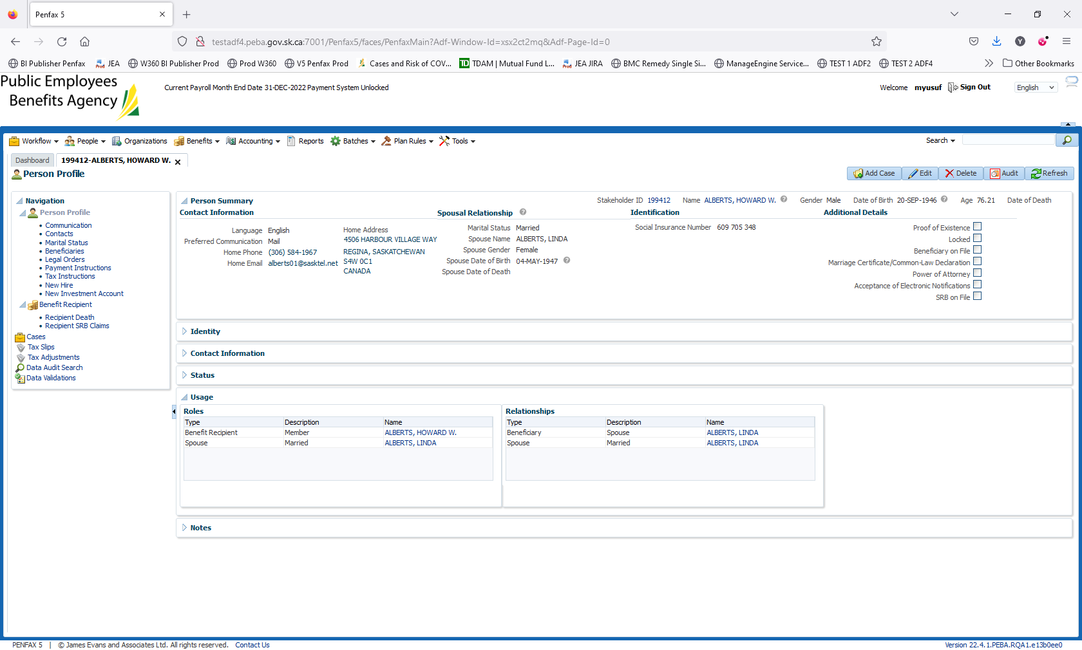

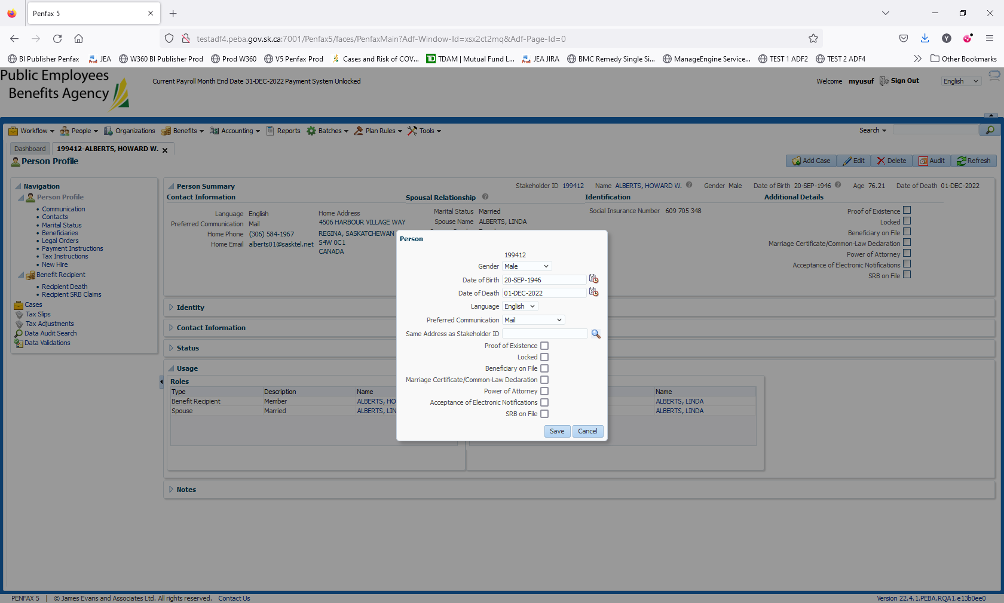

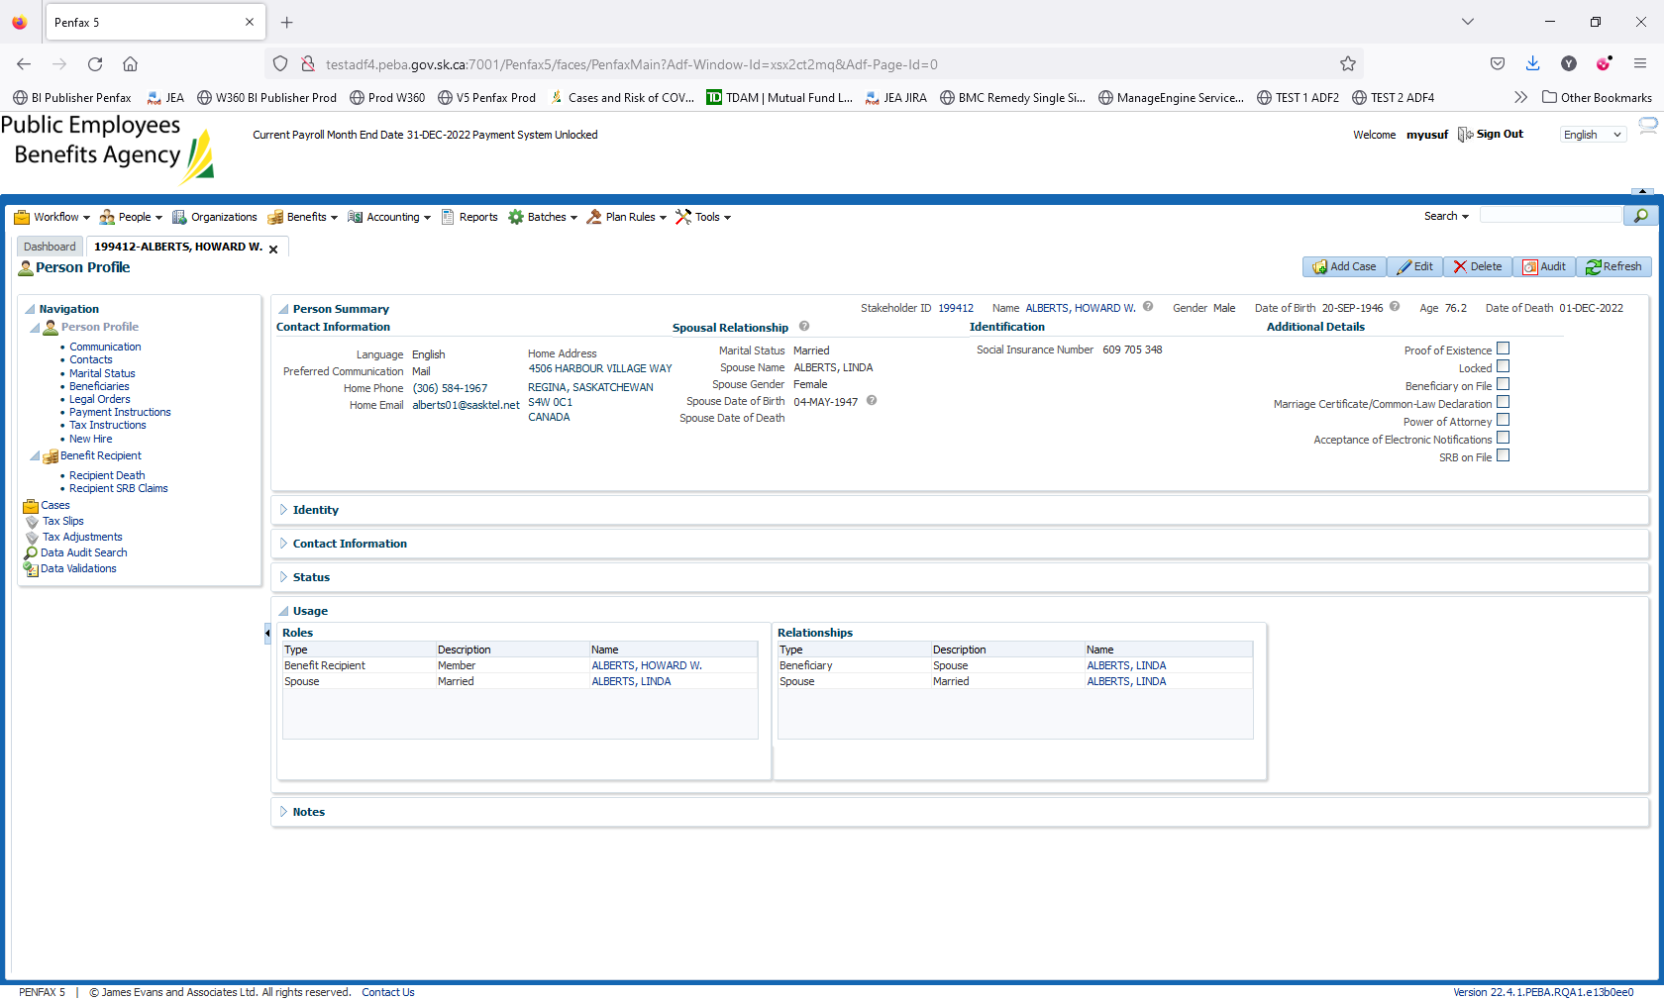

Click on New Calculation

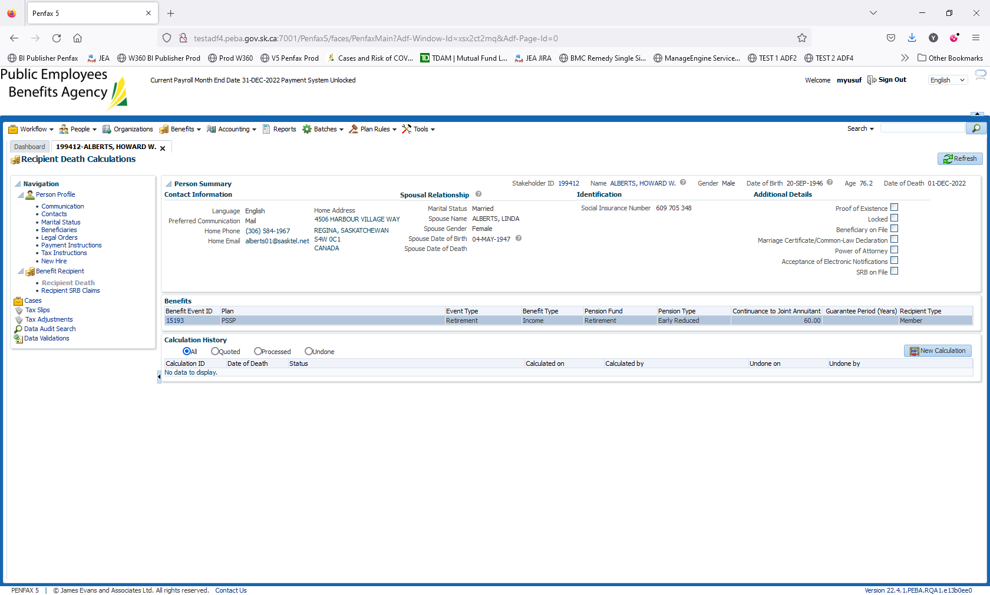

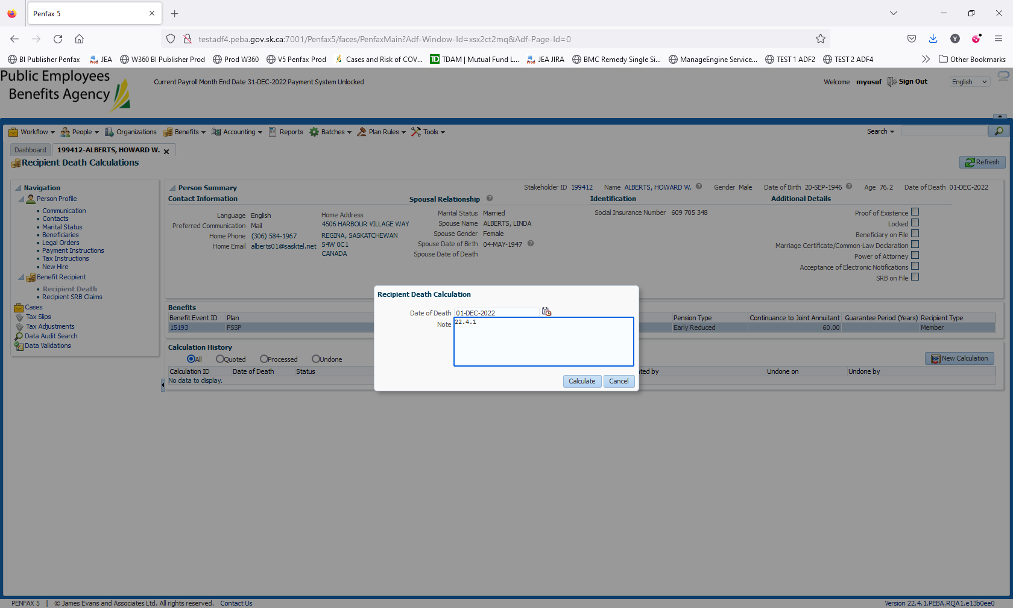

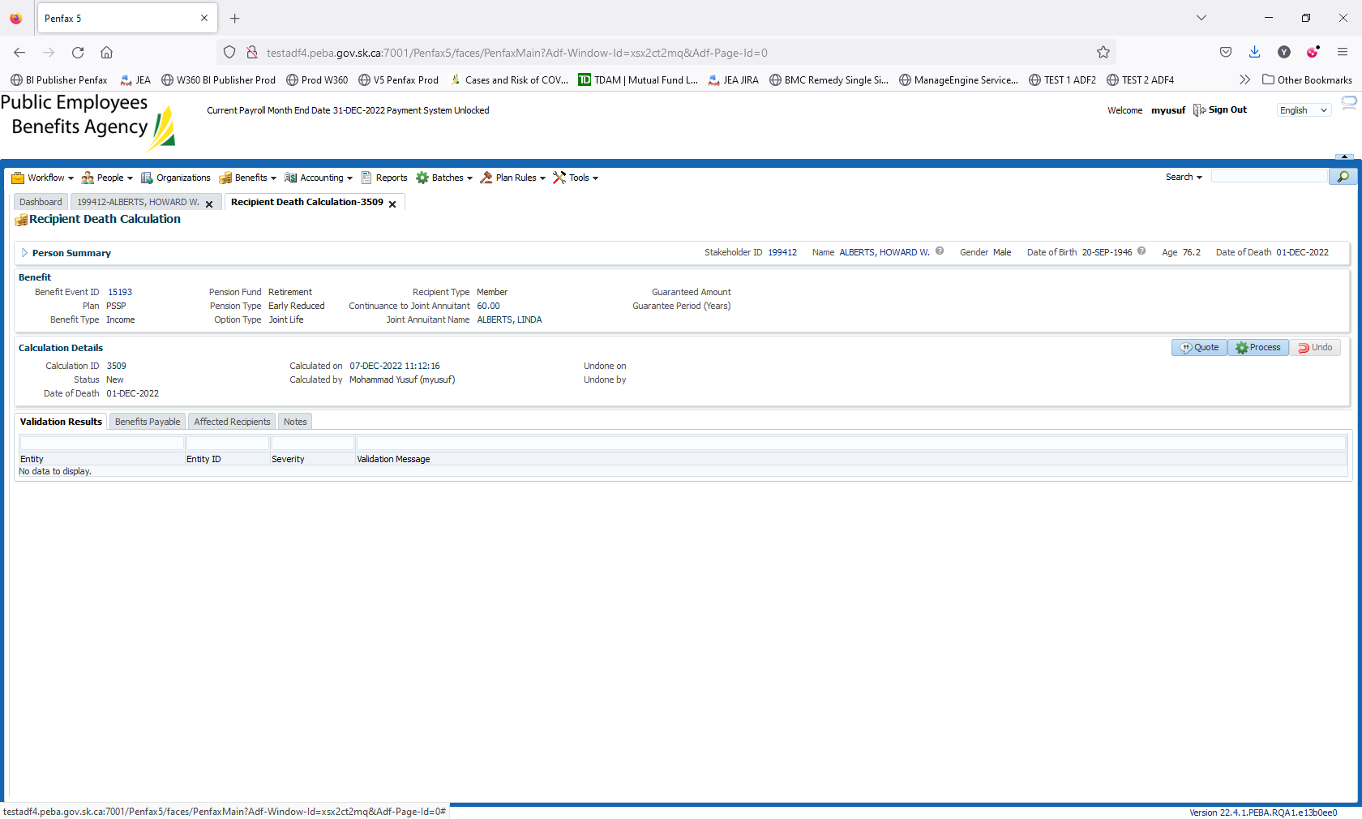

Click on Process

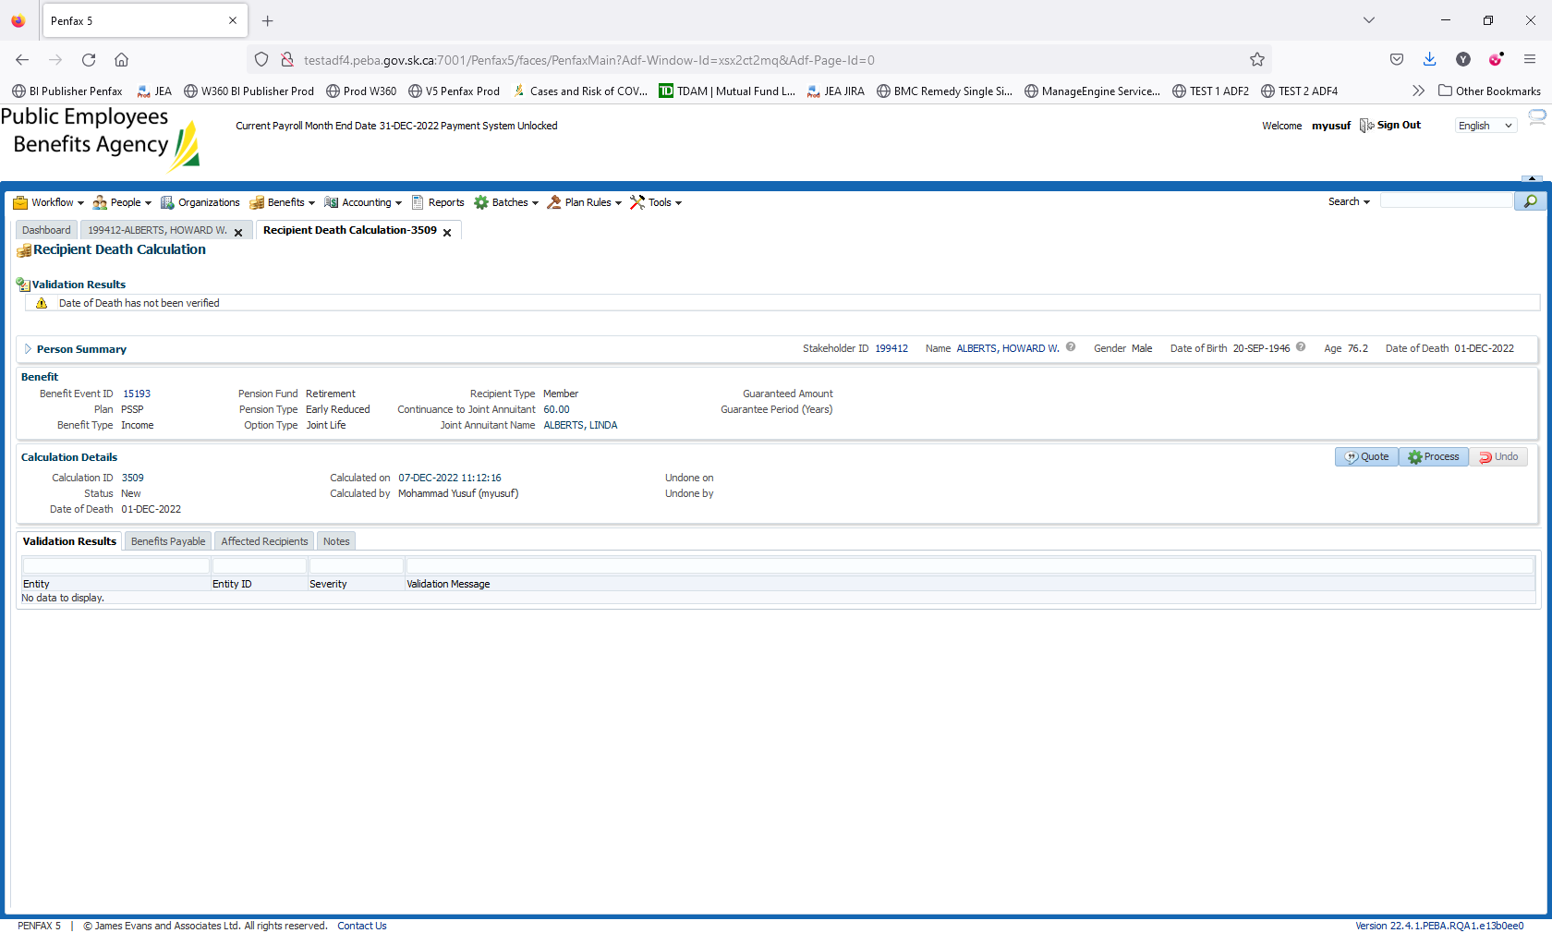

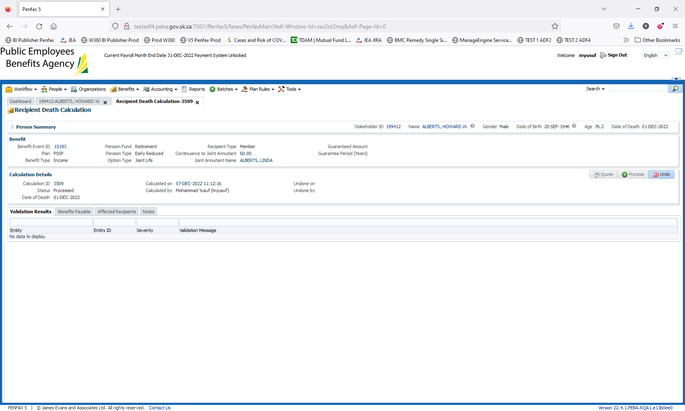

Navigate to Benefits Payable tab

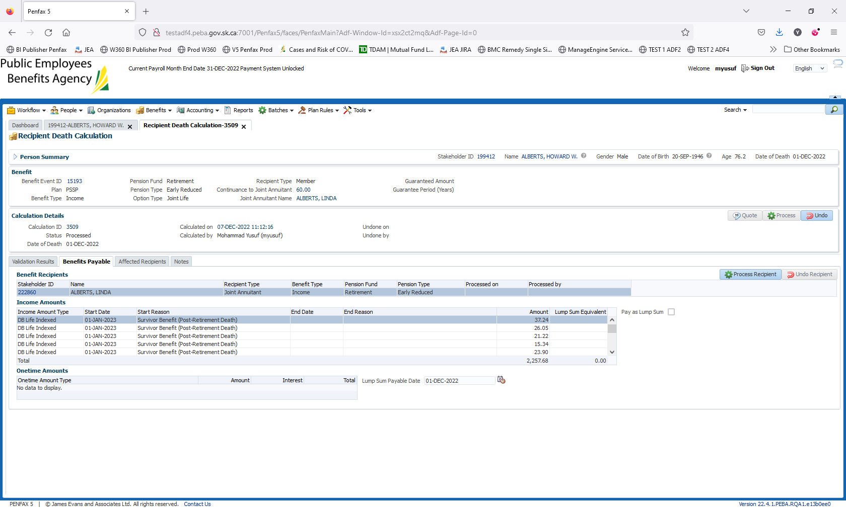

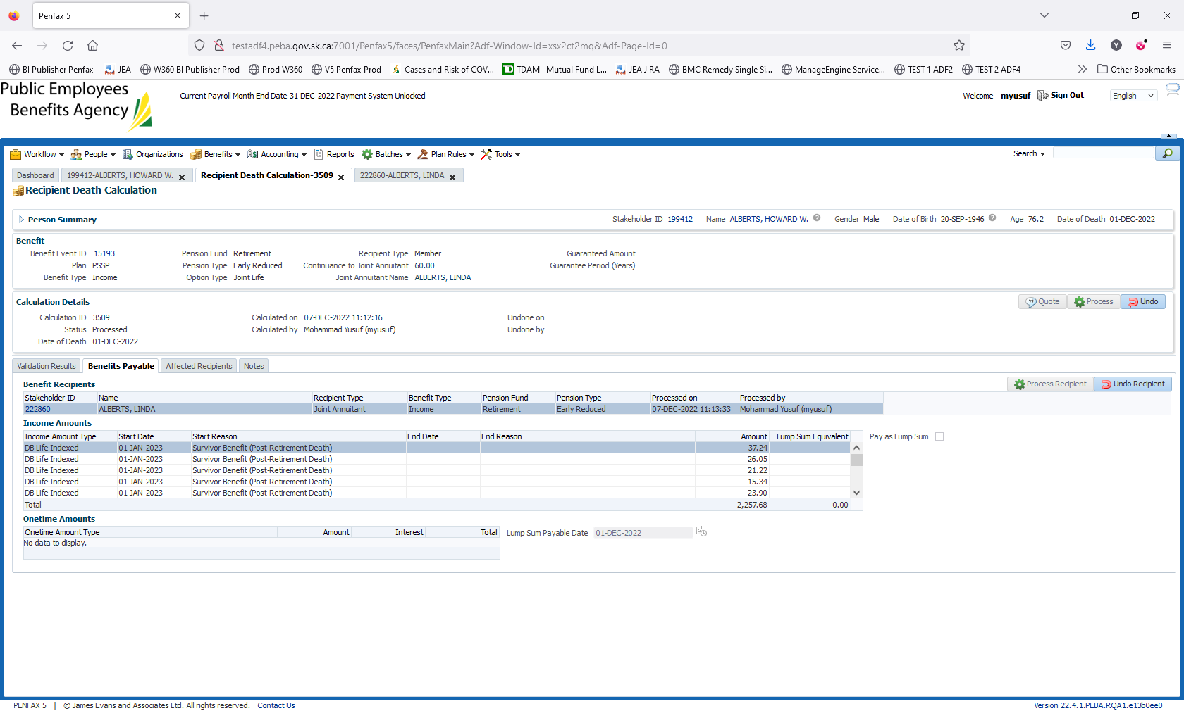

On beneficiary there is no tab for benefit recipient

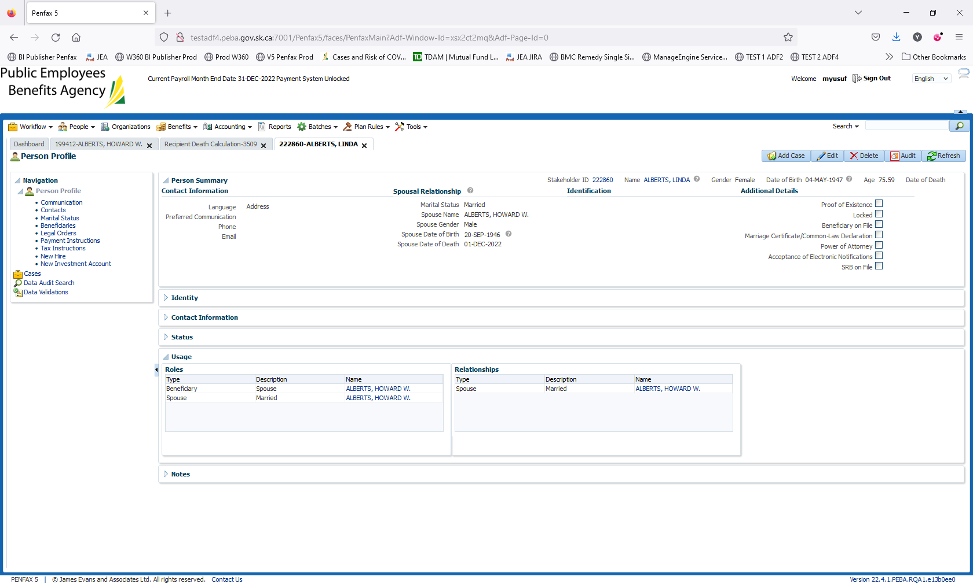

After processing the Recipient in Benefits Payable tab, it should generate the tab in Stk id 222860

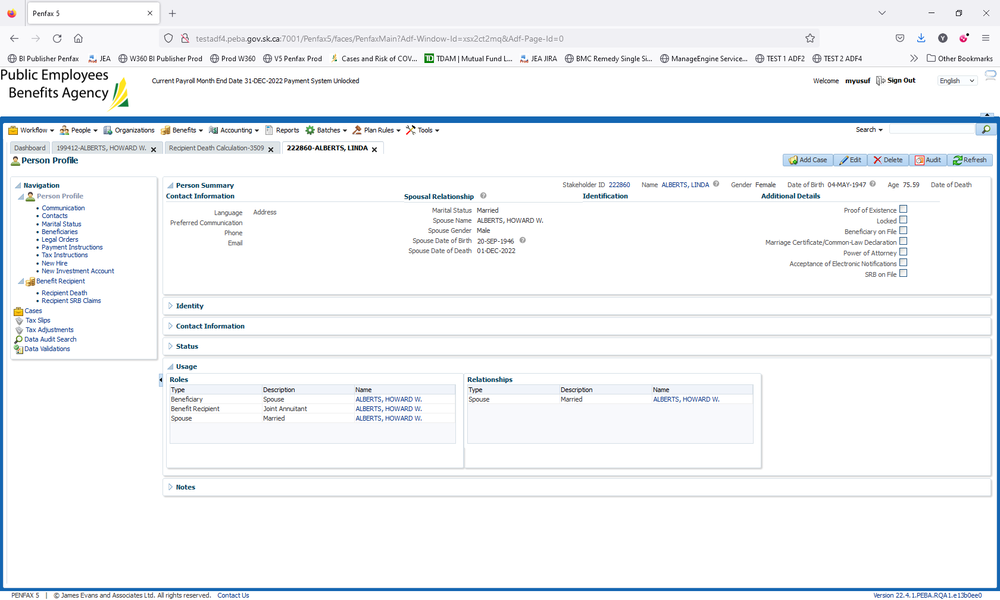

Navigate to Benefit Recipient Tab -> Authorize the Payment

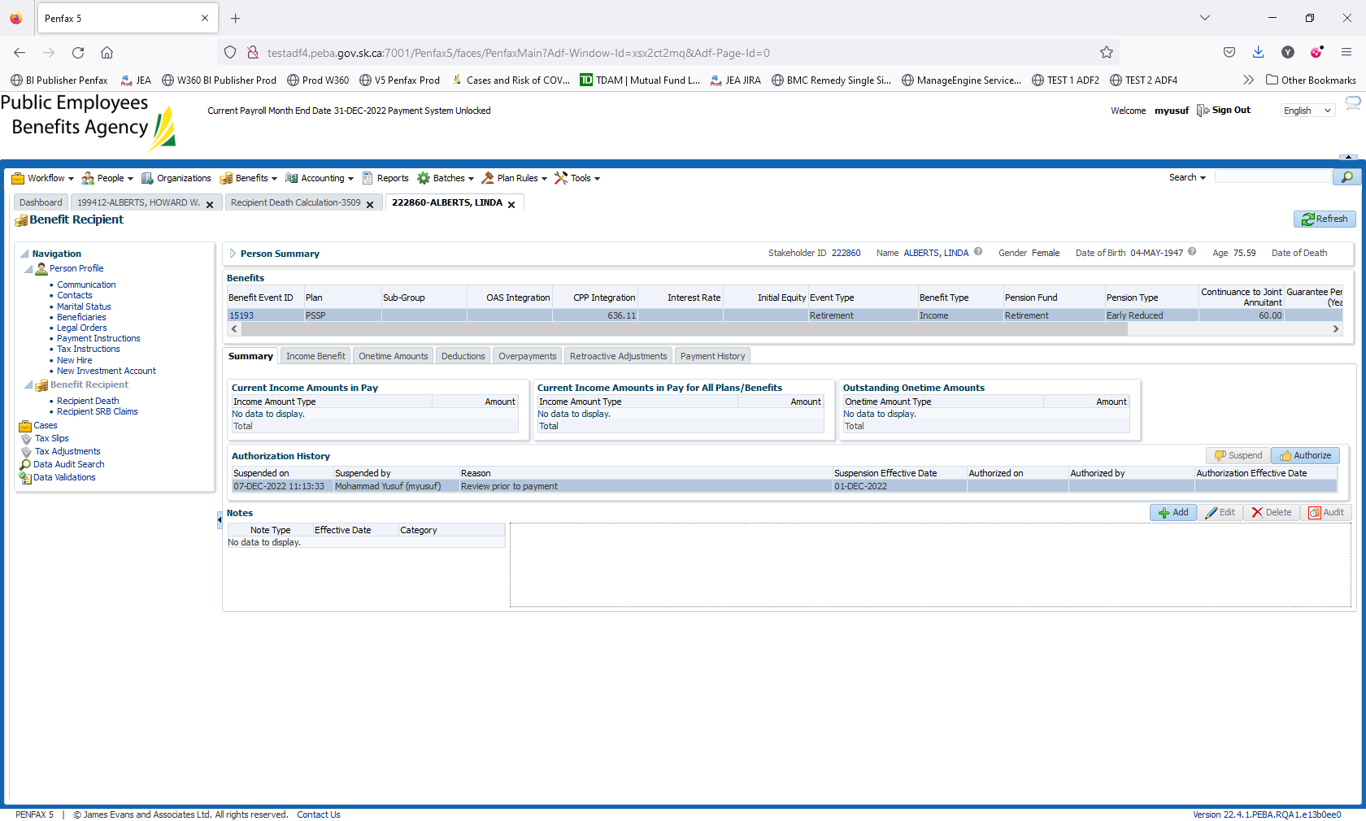

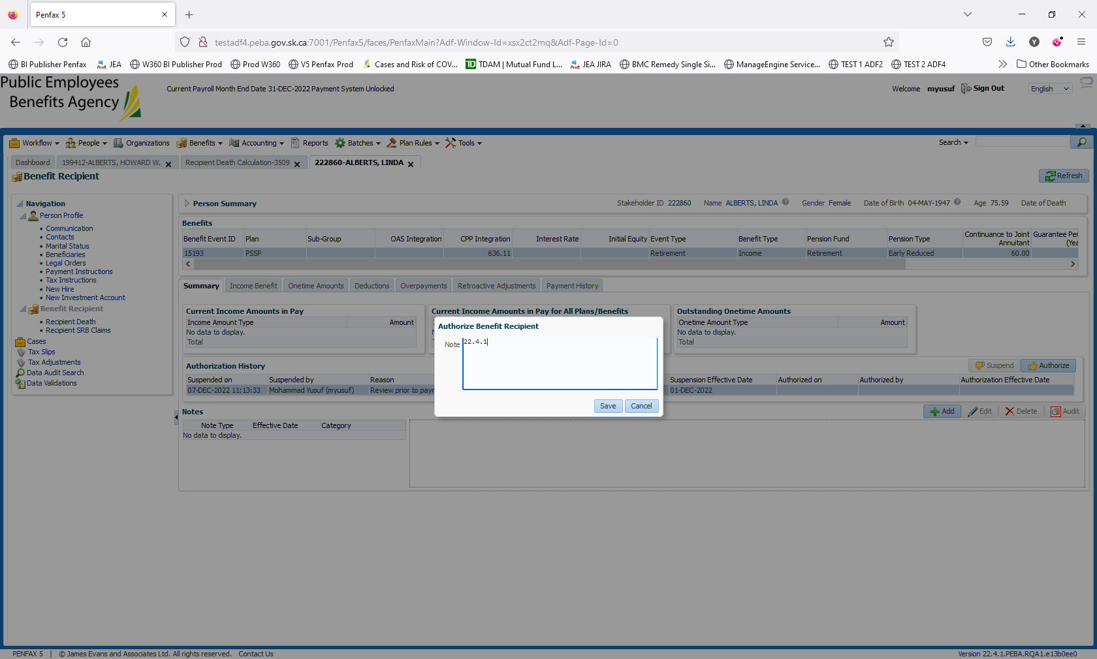

New Spousal Pension created for PSSP Member

